 

**Placement Empowerment Program**

***Cloud Computing and DevOps Centre***

* Set Up a Virtual Machine in the CloudCreate a free-tier AWS, Azure, or GCP account. Launch a virtual machine and SSH into it.

Name: Sanjay Raj S Department : IT



**Set Up a Virtual Machine in the Cloud**

**Prerequisites**

* A cloud provider account (AWS, Azure, Google Cloud, etc.)
* Basic knowledge of command-line usage
* SSH client installed (e.g., OpenSSH, PuTTY)

**Step 1: Choose a Cloud Provider**

Popular cloud providers include:

* **AWS** (Amazon Web Services)
* **Azure** (Microsoft Azure)
* **GCP** (Google Cloud Platform)
* **DigitalOcean**
* **Linode**

Sign up for an account with your preferred provider.

**Step 2: Create a Virtual Machine**

**AWS (EC2 Instance)**

1. Log in to AWS Console.
2. Navigate to **EC2 Dashboard**.
3. Click **Launch Instance**.
4. Choose an Amazon Machine Image (AMI) (e.g., Ubuntu 20.04).
5. Select an instance type (e.g., t2.micro for free tier).
6. Configure instance details (keep default for basic setup).
7. Add storage (default 8GB is sufficient for most use cases).
8. Add tags (optional but useful for organization).
9. Configure security group (allow SSH port 22).
10. Click **Launch** and select or create a key pair.
11. Click **View Instances** and wait for the instance to start.

**Azure (Virtual Machine)**

1. Log in to Azure Portal.
2. Go to **Virtual Machines**.
3. Click **Create** → **Azure Virtual Machine**.
4. Choose an image (e.g., Ubuntu 20.04 LTS).
5. Select a size (e.g., Standard_B1s for a basic VM).
6. Set up authentication (password or SSH key).
7. Configure networking (allow SSH port 22).
8. Click **Review + Create**, then **Create**.
9. Wait for deployment to complete.

**Google Cloud (Compute Engine Instance)**

1. Log in to Google Cloud Console.
2. Navigate to **Compute Engine**.
3. Click **Create Instance**.
4. Choose an OS image (e.g., Debian, Ubuntu).
5. Select machine type (e2-micro for free tier eligibility).
6. Configure networking (allow SSH port 22).
7. Click **Create**.
8. Wait for the instance to be ready.

**Step 3: Connect to the Virtual Machine**

**Using SSH (Linux/macOS/Windows with OpenSSH)**



* Replace /path/to/key.pem with your private key file.
* Replace username (e.g., ubuntu, ec2-user, admin) and vm-public-ip with your instance details.

**Using PuTTY (Windows)**

1. Open PuTTY.
2. Enter the **Public IP** of your VM.
3. Under **Connection → SSH → Auth**, load your .ppk private key.
4. Click **Open** and log in.

**Step 4: Configure the Virtual Machine**

**Update Packages**

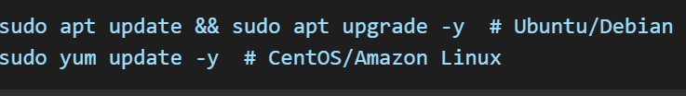

**Install Essential Software**

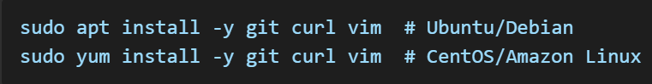

**Step 5: Set Up Firewall Rules**

**Using UFW (Ubuntu/Debian)**

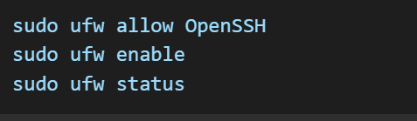

**Using Firewalld (CentOS/RHEL)**

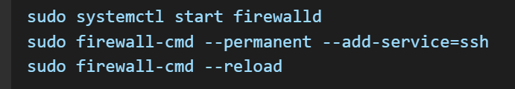

**Step 6: Enable Remote Access & Monitoring**

**Enable Remote Access**



**Monitor System Performance**

**Step 7: Secure the Virtual Machine**

* **Disable root login:**

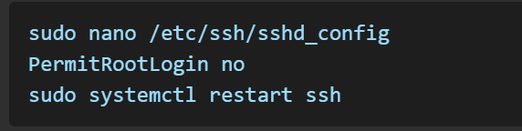

* **Set up fail2ban to prevent brute-force attacks:**

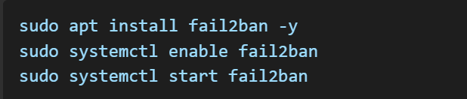

* **Use SSH keys instead of passwords for authentication.**

**Conclusion**

You have successfully set up a virtual machine in the cloud! You can now deploy applications, configure services, and scale as needed.